# Informações do estudo

Referência: Keblouti - uncoated insert

Grandeza: Rugosidade

Tipo: Ra

Material: AISI 52100

Ferramenta: CT5015 uncoated insert

Número de experimentos: 27

Observações:  
Universal lathe SN 40C type  
Workpiece: round bars66 mm of diameter and 380 mm cutting length.  
Dynamometer: KISTLER Type 9257A  
Roughnessmeter: Surftest 201 Mitutoyo

# Unidades

Velocidade: m/min

Avanço: mm/rev

Profundidade de corte: mm

Rugosidade: µm

# Dados de teste

|  |  |  |  |
| --- | --- | --- | --- |
| Rugosidade | n | f | a |
| 0.37 | 250.0 | 0.08 | 0.3 |
| 1.44 | 200.0 | 0.16 | 0.45 |
| 0.9 | 150.0 | 0.12 | 0.3 |
| 0.96 | 150.0 | 0.12 | 0.45 |
| 0.47 | 200.0 | 0.08 | 0.45 |
| 0.77 | 150.0 | 0.12 | 0.15 |

# Dados de treino

|  |  |  |  |
| --- | --- | --- | --- |
| Rugosidade | n | f | a |
| 1.39 | 150.0 | 0.16 | 0.15 |
| 0.83 | 250.0 | 0.12 | 0.45 |
| 1.27 | 250.0 | 0.16 | 0.3 |
| 1.3 | 250.0 | 0.16 | 0.45 |
| 0.96 | 150.0 | 0.08 | 0.15 |
| 0.37 | 250.0 | 0.08 | 0.45 |
| 0.74 | 200.0 | 0.12 | 0.3 |
| 1.46 | 150.0 | 0.16 | 0.45 |
| 1.45 | 150.0 | 0.16 | 0.3 |
| 0.72 | 250.0 | 0.12 | 0.3 |
| 0.57 | 250.0 | 0.12 | 0.15 |
| 0.42 | 200.0 | 0.08 | 0.3 |
| 1.26 | 250.0 | 0.16 | 0.15 |
| 0.72 | 200.0 | 0.12 | 0.15 |
| 0.6 | 150.0 | 0.08 | 0.45 |
| 1.37 | 200.0 | 0.16 | 0.3 |
| 0.4 | 200.0 | 0.08 | 0.15 |
| 0.32 | 250.0 | 0.08 | 0.15 |
| 1.37 | 200.0 | 0.16 | 0.15 |
| 0.93 | 200.0 | 0.12 | 0.45 |
| 0.8 | 150.0 | 0.08 | 0.3 |

# RN

Número de neurônios: 88

Taxa de aprendizado: 1.000000e-01

Número de épocas: 926

2° camada: False

Função de ativação: tanh

# Erros

**Dados de teste**

* Erro relativo médio: 17.2
* Coeficiente de correlação: 0.95
* Coeficiente de determinação: 0.9
* MSE: 0.02
* RMSE: 0.14

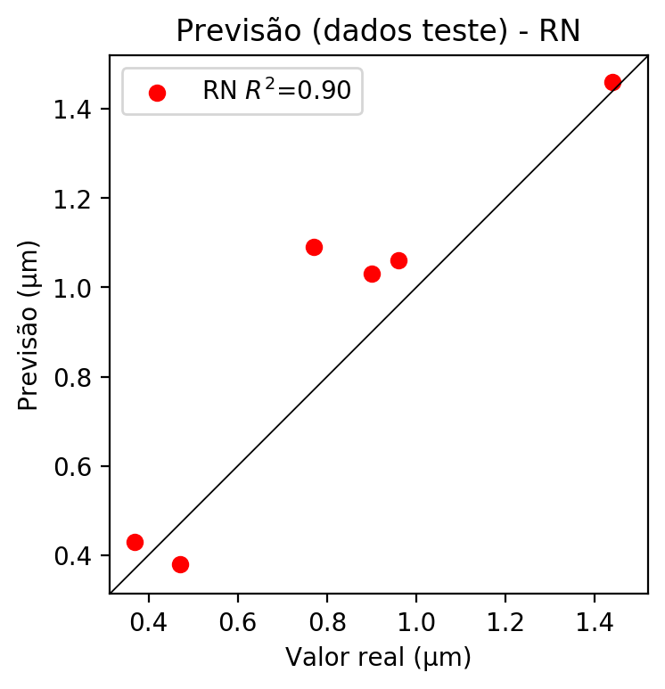

**Dados de treino**

* Erro relativo médio: 0.0
* Coeficiente de correlação: 1.0
* Coeficiente de determinação: 1.0
* MSE: 0.0
* RMSE: 0.0

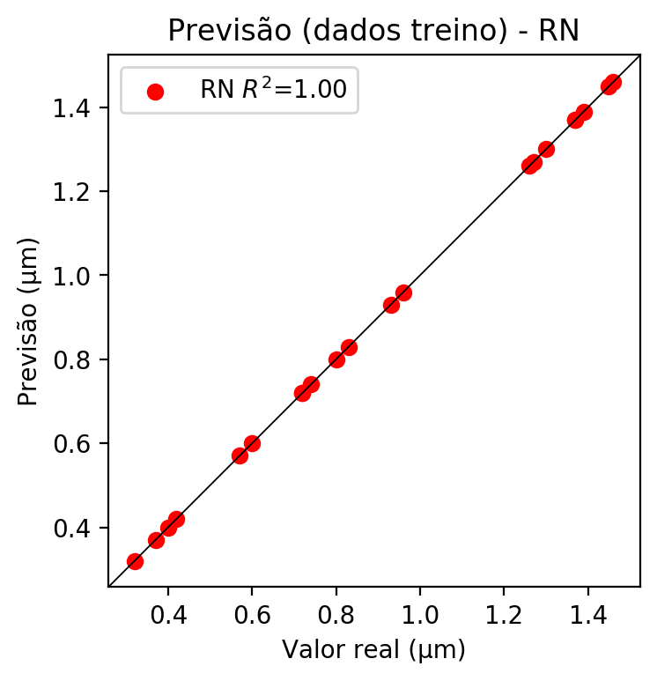

# Pesos

Pesos - camada oculta 1

[[-1.01130450e+00 -4.53612477e-01 2.90733814e-01 9.58277047e-01  
 -8.15453380e-02 1.28762931e-01 7.72990048e-01 2.15385780e-01  
 5.48340321e-01 -5.81484996e-02 2.64269173e-01 -6.88246340e-02  
 2.23157741e-02 8.28027844e-01 4.06374305e-01 7.21374303e-02  
 -7.92164579e-02 5.74121833e-01 2.70224959e-01 -2.37851694e-01  
 -2.79679924e-01 -3.14734459e-01 1.70024987e-02 -2.95142293e-01  
 3.23751308e-02 8.31641480e-02 -3.06479543e-01 -5.38310885e-01  
 -2.67541975e-01 2.98834562e-01 2.38175485e-02 3.38028401e-01  
 1.95145935e-01 3.08282107e-01 6.58531934e-02 2.95415908e-01  
 8.13834444e-02 -1.21124990e-01 5.94586730e-01 -1.39121143e-02  
 -3.92115563e-02 -8.19381922e-02 -3.23136121e-01 -2.86874056e-01  
 -8.57054219e-02 -1.05333664e-01 5.80436699e-02 3.99945617e-01  
 -1.80838719e-01 -3.21036011e-01 -4.32310909e-01 -2.77722865e-01  
 -4.00569215e-02 -6.04812279e-02 9.61805210e-02 -6.59466013e-02  
 4.12418023e-02 7.30453551e-01 4.57797706e-01 2.16126844e-01  
 -3.52159679e-01 2.29372650e-01 5.34951329e-01 -6.15253113e-02  
 -2.95336962e-01 3.54864299e-01 6.44785404e-01 -3.18674564e-01  
 2.73526728e-01 8.67686987e-01 8.71319044e-03 3.72316279e-02  
 5.81338882e-01 2.09663570e-01 -3.10644265e-02 2.34952301e-01  
 -5.09450436e-02 -5.50364792e-01 -5.52297235e-01 -4.97072227e-02  
 -8.35892707e-02 3.11490715e-01 2.92416751e-01 -1.99849950e-03  
 2.14976475e-01 -3.43319863e-01 3.91082138e-01 2.04157904e-01]  
 [-5.15772641e-01 3.51549298e-01 -3.61427993e-01 3.77746403e-01  
 -2.69105621e-02 1.38416976e-01 -3.24461430e-01 3.37363929e-01  
 -4.87602502e-01 -2.25840822e-01 -4.14122760e-01 1.09227542e-02  
 -7.75661469e-02 -1.81989178e-01 3.73961926e-01 7.58644342e-02  
 -2.08680872e-02 -5.80070019e-01 -4.78157699e-01 3.13695997e-01  
 3.67909074e-01 2.06543088e-01 2.67265365e-02 -2.19035253e-01  
 -8.42615664e-02 4.00773529e-03 5.13252616e-01 4.80675042e-01  
 3.53811353e-01 -2.05309734e-01 1.07530028e-01 -5.68282604e-01  
 -1.53105095e-01 -6.00689948e-01 4.66020070e-02 -1.72855541e-01  
 1.25897694e+00 -2.32931465e-01 1.71768486e-01 1.44943565e-01  
 2.85741733e-03 -1.51372939e-01 3.06347877e-01 3.91375810e-01  
 -2.30370104e-01 -1.04620390e-01 1.21237293e-01 1.43097386e-01  
 1.71793371e-01 6.99281394e-01 -1.76753134e-01 4.53367293e-01  
 -4.75546382e-02 -1.06425846e+00 2.60838479e-01 -1.08382069e-02  
 3.84185389e-02 5.92476428e-01 -4.36215615e-03 -3.00506264e-01  
 6.33245170e-01 -2.23885924e-01 1.15828633e-01 -7.84528558e-04  
 3.98789734e-01 -5.31820595e-01 -4.97024447e-01 -3.55308414e-01  
 -1.27652600e-01 3.62144887e-01 -4.70616110e-02 7.21084932e-03  
 -4.05480385e-01 -1.81264013e-01 -1.50464615e-02 -6.48474768e-02  
 5.00631938e-03 -1.29299849e-01 3.58263344e-01 8.07654187e-02  
 -4.58659930e-03 -6.24959946e-01 -6.31004393e-01 -1.78435165e-02  
 -1.62246376e-01 2.76765019e-01 -3.65012378e-01 -2.26498425e-01]  
 [ 6.75455406e-02 1.21601477e-01 1.08313508e-01 -7.21602976e-01  
 4.91383255e-01 2.58985668e-01 7.46366382e-01 -3.78106326e-01  
 -1.93186346e-02 -1.60594434e-02 6.29330337e-01 5.55380106e-01  
 -5.83998077e-02 -1.94762781e-01 1.66298732e-01 -1.20750070e-01  
 -1.21360242e-01 1.51616573e-01 2.96060592e-01 -5.07383682e-02  
 7.40486562e-01 2.85125911e-01 -3.78284156e-02 -2.34075457e-01  
 2.22041428e-01 -6.14846766e-01 9.67781007e-01 2.68503353e-02  
 -6.90963119e-02 -3.45835835e-01 -9.08331424e-02 2.83077192e-02  
 -1.95735916e-02 8.21016014e-01 1.08909467e-03 -3.03221345e-01  
 4.61199492e-01 2.37469628e-01 3.89527380e-01 -1.13254264e-01  
 2.31139719e-01 2.31203720e-01 5.94246864e-01 5.63081980e-01  
 2.58151770e-01 4.99649644e-02 -6.23180628e-01 3.99994105e-01  
 5.71417689e-01 -7.78105140e-01 -2.97907054e-01 -7.41196513e-01  
 9.30545852e-03 -4.77190971e-01 -2.76728034e-01 -3.59975882e-02  
 -2.31201015e-02 -5.95543146e-01 5.50603330e-01 2.80427068e-01  
 -8.64271879e-01 -4.16584551e-01 5.18873096e-01 -1.02902420e-01  
 4.58354771e-01 1.44472942e-01 5.33922613e-01 -8.32707584e-02  
 2.96984613e-01 3.30874950e-01 6.46606609e-02 -9.94395465e-04  
 3.74220252e-01 5.38440421e-02 1.47575438e-01 -4.46096569e-01  
 1.58450052e-01 -4.27145630e-01 9.29802060e-02 8.94025788e-02  
 5.61157942e-01 6.00342572e-01 6.48928702e-01 -4.61948290e-02  
 -6.52492404e-01 4.61596161e-01 1.91956460e-02 -6.10012233e-01]]

Bias - camada oculta

[ 0.81776214 0.17066057 0.3400212 0.17721952 -0.5013967 0.09205996  
 0.7763402 -0.13131131 -0.18288015 0.19931015 0.0935097 -0.12143224  
 0.6747874 0.18144403 -0.19059628 -0.6819896 -0.10101166 -0.08573803  
 0.24869542 -0.42307976 0.3637362 0.48841295 -0.0680797 0.02776912  
 0.11890281 0.33533084 0.45599148 0.17069253 -0.38185066 -0.38713193  
 -0.16338174 -0.24734479 0.3501724 -0.05549637 -0.00424369 -0.37980938  
 -0.64755464 0.29620805 -0.2268438 -0.35993078 -0.30344945 0.03104485  
 0.6601731 0.1345003 0.38801417 0.08238747 0.49990764 -0.07458007  
 -0.08649428 0.06070324 0.11636362 -0.12652883 0.03052271 0.5550266  
 -0.3517071 -0.05485795 -0.01541161 0.2303323 -0.06661596 0.2830514  
 0.0743698 0.09985895 -0.17950286 -0.12912306 0.02137079 -0.24184157  
 0.34027436 0.12053188 0.18593954 -0.47166216 0.1071827 0.03583502  
 0.2458657 0.32038614 -0.21932152 -0.32243162 -0.31232217 0.17944126  
 0.14890486 -0.5804997 -0.37442848 0.05911587 0.02535865 0.132455  
 0.04775389 0.5684997 -0.27709767 0.02994969]

Pesos - camada saída

[[-3.44829410e-01 2.16138855e-01 6.44009039e-02 -1.97330996e-01  
 -1.26848936e-01 -6.08922448e-03 -3.43878418e-01 -8.53424985e-03  
 -2.56077707e-01 4.81188437e-03 7.80518278e-02 -6.67525977e-02  
 4.16642241e-02 -3.13113272e-01 3.18829343e-02 -2.37582289e-02  
 4.23780782e-03 -2.65141666e-01 9.57538188e-02 -1.24319538e-01  
 -5.73272668e-02 1.02609340e-02 1.45850048e-04 -1.75285656e-02  
 -3.90642136e-03 1.18822530e-01 -9.21513587e-02 2.85108626e-01  
 -9.48072225e-02 7.35095236e-03 -8.27998575e-03 3.89026925e-02  
 6.13969043e-02 4.42925878e-02 -6.88065425e-04 3.26613011e-03  
 4.88708258e-01 8.62466078e-03 1.39042228e-01 -9.47920419e-03  
 -4.62585613e-02 -5.92770055e-03 -5.30299172e-03 -8.82241279e-02  
 1.32550159e-02 1.03439484e-03 1.68225944e-01 5.12740500e-02  
 -8.15255642e-02 -1.14278488e-01 -7.31827319e-02 -1.66346654e-02  
 2.31170864e-03 -3.63379896e-01 -1.80767588e-02 -8.23378272e-04  
 -8.20524176e-04 -4.15768884e-02 8.06183666e-02 9.30393413e-02  
 -5.84594905e-02 8.57062712e-02 9.64189768e-02 1.03699986e-03  
 -1.04206979e-01 2.11456697e-02 -2.69660234e-01 1.07907103e-02  
 7.08686411e-02 2.42649138e-01 2.59364466e-03 -8.16308137e-04  
 -2.87750930e-01 8.74702632e-02 -1.80788860e-02 3.89919314e-03  
 -2.50187237e-02 -1.18286930e-01 2.74463832e-01 -3.50313857e-02  
 -1.17924660e-01 1.21302024e-01 1.14342146e-01 3.44578014e-03  
 1.04516232e-02 1.10845286e-02 -2.70845205e-01 8.54169279e-02]]

# Iterações

|  |  |  |  |  |  |  |
| --- | --- | --- | --- | --- | --- | --- |
| Média | Desvio | n | ln | 2° camada | Função | Épocas |
| -0.1382 | 0.066 | 10 | 0.1 | False | relu | 38 |
| -0.0586 | 0.0445 | 17 | 0.1 | True | relu | 716 |
| -0.1153 | 0.0526 | 7 | 0.01 | True | tanh | 130 |
| -0.3049 | 0.2107 | 19 | 0.001 | False | tanh | 282 |
| -0.1237 | 0.0708 | 29 | 0.001 | False | relu | 469 |
| -0.0567 | 0.0301 | 88 | 0.1 | False | tanh | 926 |
| -0.0782 | 0.0431 | 95 | 0.0001 | True | relu | 984 |
| -0.0682 | 0.0204 | 10 | 0.01 | True | tanh | 865 |
| -0.7144 | 0.2524 | 58 | 0.001 | True | relu | 8 |
| -0.1631 | 0.0995 | 9 | 0.01 | False | tanh | 514 |
| -0.106 | 0.063 | 73 | 0.0001 | True | relu | 729 |
| -0.0816 | 0.0573 | 22 | 0.001 | True | relu | 543 |
| -0.0752 | 0.03 | 25 | 0.1 | True | relu | 562 |
| -0.1392 | 0.0858 | 53 | 0.001 | False | relu | 498 |
| -0.0761 | 0.0513 | 83 | 0.01 | True | relu | 337 |
| -0.262 | 0.1925 | 99 | 0.01 | False | tanh | 16 |
| -0.0859 | 0.0558 | 23 | 0.01 | False | relu | 472 |
| -0.1062 | 0.0204 | 24 | 0.001 | True | relu | 778 |
| -0.1213 | 0.0335 | 58 | 0.01 | True | tanh | 382 |
| -0.3144 | 0.1788 | 35 | 0.1 | False | tanh | 596 |

# RL

# Coeficientes

[ 0. -0.34728199 0.89383717 0.0504287 ]

# Erros

**Dados de teste**

* Erro relativo médio: 15.99
* Coeficiente de correlação: 0.94
* Coeficiente de determinação: 0.88
* MSE: 0.02
* RMSE: 0.14

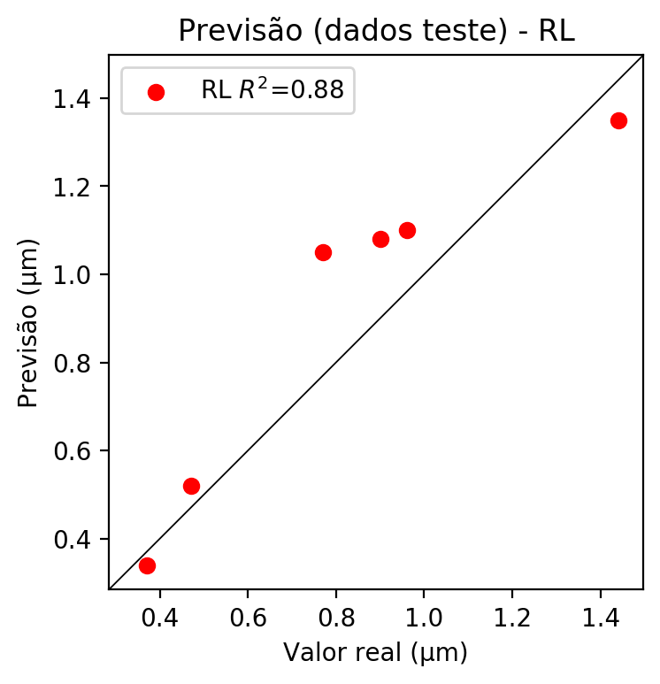

**Dados de treino**

* Erro relativo médio: 11.31
* Coeficiente de correlação: 0.95
* Coeficiente de determinação: 0.91
* MSE: 0.01
* RMSE: 0.1

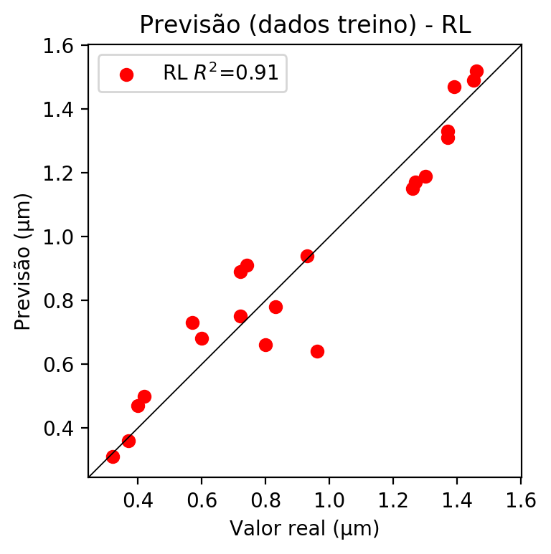

# RP2

# Coeficientes

[ 0. -0.32835785 0.90666586 0.02728995 0.10717191 0.13399757  
 0.10974241 0.17646853 0.05266574 0.01867457]

# Erros

**Dados de teste**

* Erro relativo médio: 12.62
* Coeficiente de correlação: 0.94
* Coeficiente de determinação: 0.88
* MSE: 0.02
* RMSE: 0.14

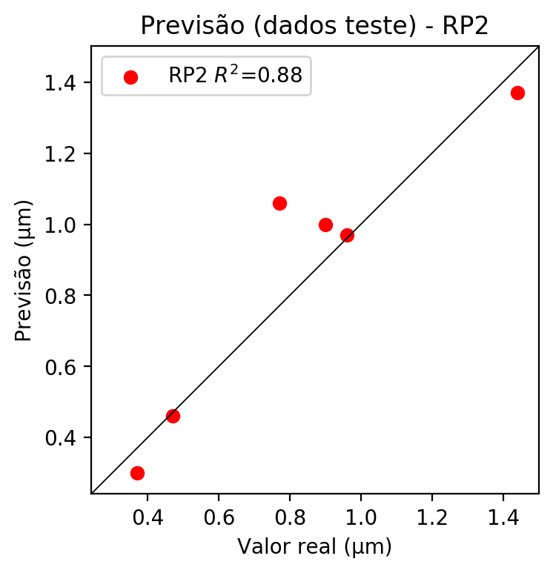

**Dados de treino**

* Erro relativo médio: 8.11
* Coeficiente de correlação: 0.98
* Coeficiente de determinação: 0.97
* MSE: 0.0
* RMSE: 0.0

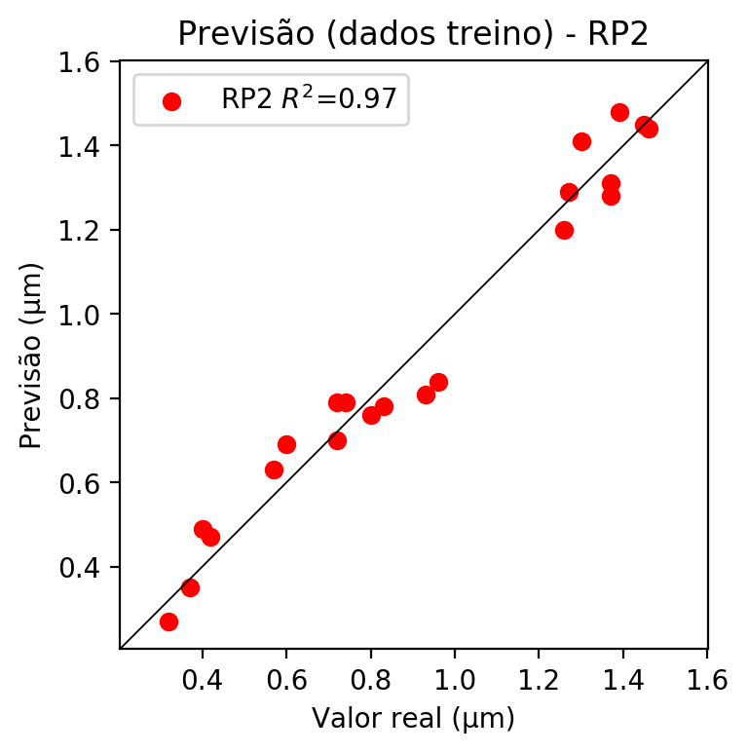

# RP3

# Coeficientes

[ 0. -0.11255867 0.34361086 0.0750047 0.1237002 0.12498476  
 0.08609985 0.17095061 0.08519524 0.00071696 -0.16258474 -0.1690236  
 -0.0430144 0.01626526 -0.08171781 0.0057977 0.4963268 -0.15333158  
 0.02881142 0.10834012]

# Erros

**Dados de teste**

* Erro relativo médio: 14.02
* Coeficiente de correlação: 0.97
* Coeficiente de determinação: 0.93
* MSE: 0.02
* RMSE: 0.14

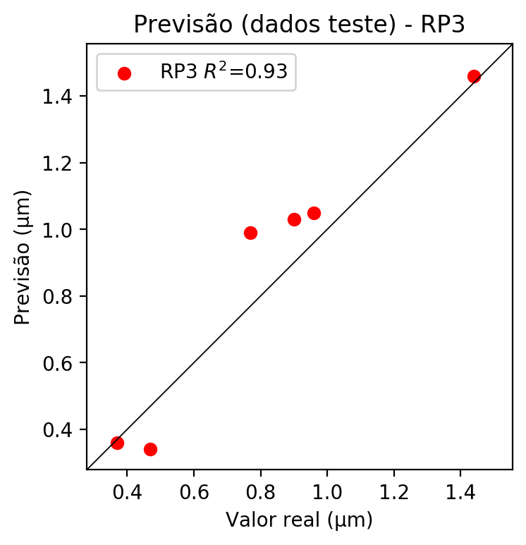

**Dados de treino**

* Erro relativo médio: 2.22
* Coeficiente de correlação: 1.0
* Coeficiente de determinação: 1.0
* MSE: 0.0
* RMSE: 0.0

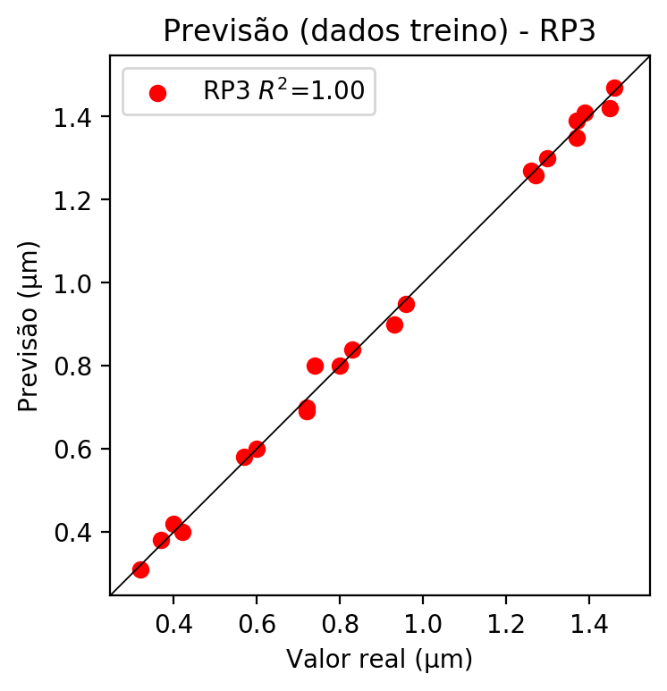

# RP4

# Coeficientes

[ 5.55111512e-17 -5.40734127e-02 3.30288520e-01 7.30111465e-02  
 3.34205712e-02 1.17083880e-02 3.46358960e-02 8.96770155e-02  
 9.00383364e-03 4.91777182e-02 -7.81060406e-02 -1.72473113e-01  
 -1.11930608e-01 -6.85722036e-02 -8.17178075e-02 -3.13241723e-02  
 4.77083418e-01 -8.12205736e-02 5.36108471e-02 1.05460545e-01  
 4.82741583e-02 1.69121159e-02 5.00296275e-02 5.97324043e-02  
 3.26582218e-02 -1.03742153e-01 1.69121159e-02 -6.53164436e-02  
 4.76975268e-02 5.00296275e-02 1.29533467e-01 1.30055375e-02  
 -5.52171793e-02 1.30055375e-02 7.10344818e-02]

# Erros

**Dados de teste**

* Erro relativo médio: 13.55
* Coeficiente de correlação: 0.95
* Coeficiente de determinação: 0.91
* MSE: 0.01
* RMSE: 0.1

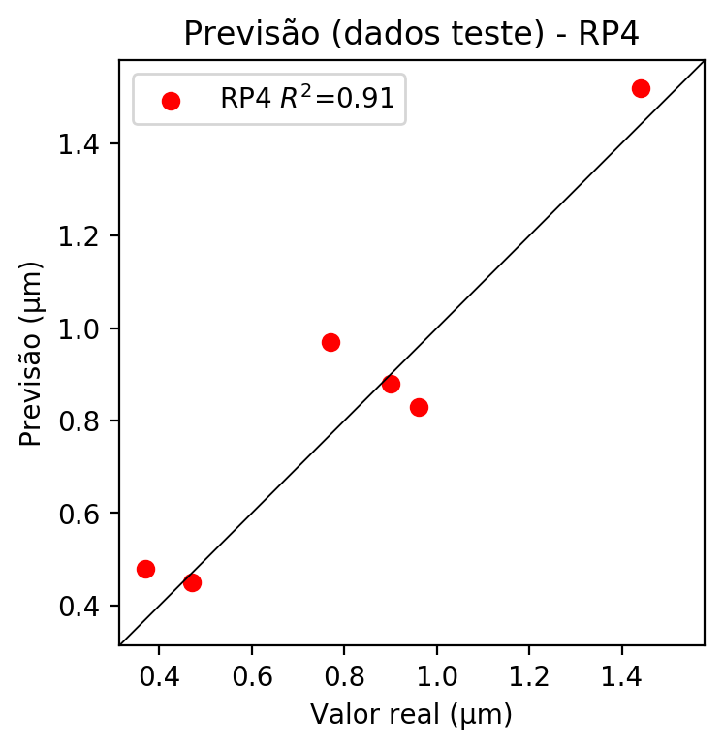

**Dados de treino**

* Erro relativo médio: 0.0
* Coeficiente de correlação: 1.0
* Coeficiente de determinação: 1.0
* MSE: 0.0
* RMSE: 0.0

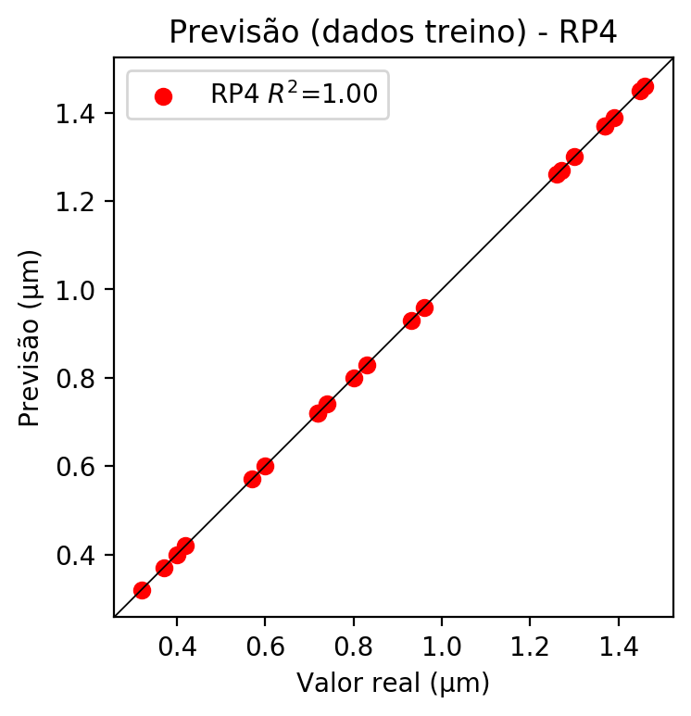

# Geral

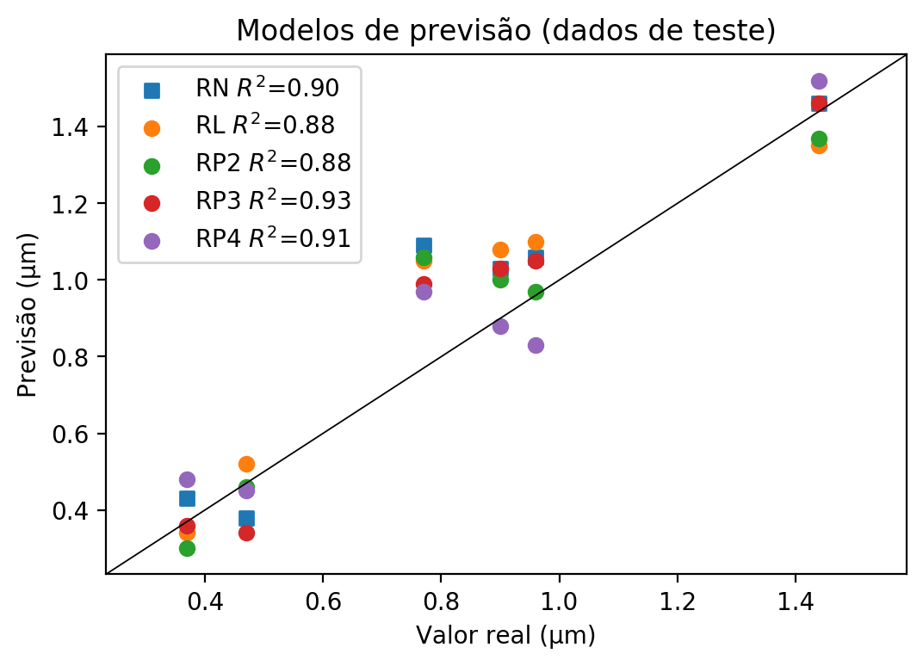

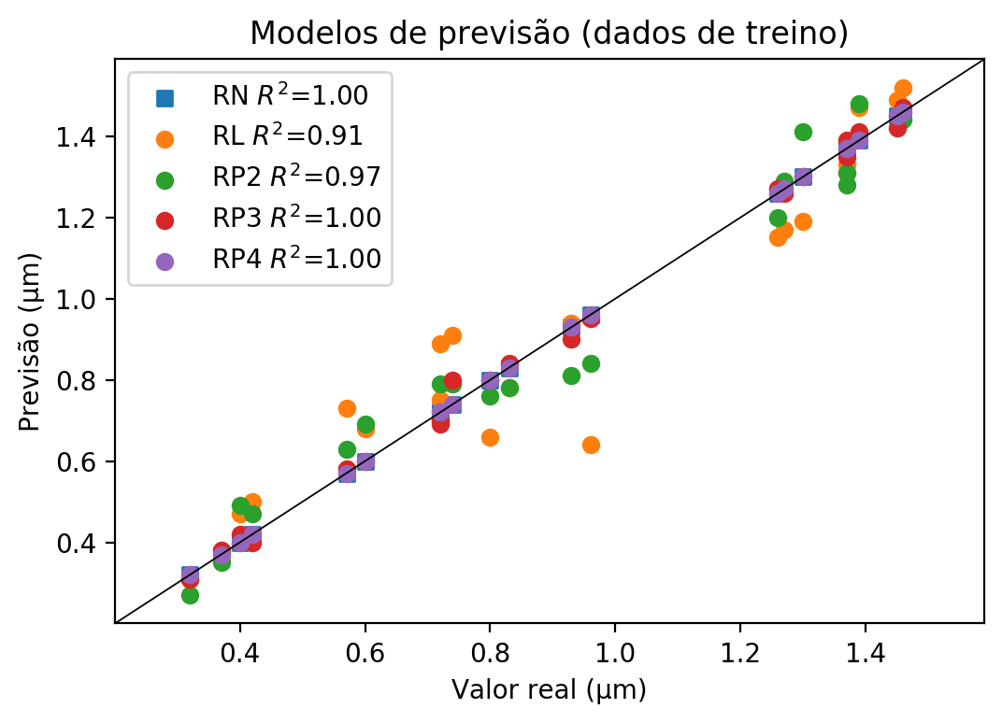

**Dados de teste**

|  |  |  |  |  |  |  |  |  |  |  |
| --- | --- | --- | --- | --- | --- | --- | --- | --- | --- | --- |
| Valor real | RN Previsto | RN Erro (%) | RL Previsto | RL Erro (%) | RP2 Previsto | RP2 Erro (%) | RP3 Previsto | RP3 Erro (%) | RP4 Previsto | RP4 Erro (%) |
| 0.37 | 0.43 | 16.22 | 0.34 | 8.11 | 0.3 | 18.92 | 0.36 | 2.7 | 0.48 | 29.73 |
| 1.44 | 1.46 | 1.39 | 1.35 | 6.25 | 1.37 | 4.86 | 1.46 | 1.39 | 1.52 | 5.56 |
| 0.9 | 1.03 | 14.44 | 1.08 | 20.0 | 1.0 | 11.11 | 1.03 | 14.44 | 0.88 | 2.22 |
| 0.96 | 1.06 | 10.42 | 1.1 | 14.58 | 0.97 | 1.04 | 1.05 | 9.38 | 0.83 | 13.54 |
| 0.47 | 0.38 | 19.15 | 0.52 | 10.64 | 0.46 | 2.13 | 0.34 | 27.66 | 0.45 | 4.26 |
| 0.77 | 1.09 | 41.56 | 1.05 | 36.36 | 1.06 | 37.66 | 0.99 | 28.57 | 0.97 | 25.97 |

**Dados de treino**

|  |  |  |  |  |  |  |  |  |  |  |
| --- | --- | --- | --- | --- | --- | --- | --- | --- | --- | --- |
| Valor real | RN Previsto | RN Erro (%) | RL Previsto | RL Erro (%) | RP2 Previsto | RP2 Erro (%) | RP3 Previsto | RP3 Erro (%) | RP4 Previsto | RP4 Erro (%) |
| 1.39 | 1.39 | 0.0 | 1.47 | 5.76 | 1.48 | 6.47 | 1.41 | 1.44 | 1.39 | 0.0 |
| 0.83 | 0.83 | 0.0 | 0.78 | 6.02 | 0.78 | 6.02 | 0.84 | 1.2 | 0.83 | 0.0 |
| 1.27 | 1.27 | 0.0 | 1.17 | 7.87 | 1.29 | 1.57 | 1.26 | 0.79 | 1.27 | 0.0 |
| 1.3 | 1.3 | 0.0 | 1.19 | 8.46 | 1.41 | 8.46 | 1.3 | 0.0 | 1.3 | 0.0 |
| 0.96 | 0.96 | 0.0 | 0.64 | 33.33 | 0.84 | 12.5 | 0.95 | 1.04 | 0.96 | 0.0 |
| 0.37 | 0.37 | 0.0 | 0.36 | 2.7 | 0.35 | 5.41 | 0.38 | 2.7 | 0.37 | 0.0 |
| 0.74 | 0.74 | 0.0 | 0.91 | 22.97 | 0.79 | 6.76 | 0.8 | 8.11 | 0.74 | 0.0 |
| 1.46 | 1.46 | 0.0 | 1.52 | 4.11 | 1.44 | 1.37 | 1.47 | 0.68 | 1.46 | 0.0 |
| 1.45 | 1.45 | 0.0 | 1.49 | 2.76 | 1.45 | 0.0 | 1.42 | 2.07 | 1.45 | 0.0 |
| 0.72 | 0.72 | 0.0 | 0.75 | 4.17 | 0.7 | 2.78 | 0.7 | 2.78 | 0.72 | 0.0 |
| 0.57 | 0.57 | 0.0 | 0.73 | 28.07 | 0.63 | 10.53 | 0.58 | 1.75 | 0.57 | 0.0 |
| 0.42 | 0.42 | 0.0 | 0.5 | 19.05 | 0.47 | 11.9 | 0.4 | 4.76 | 0.42 | 0.0 |
| 1.26 | 1.26 | 0.0 | 1.15 | 8.73 | 1.2 | 4.76 | 1.27 | 0.79 | 1.26 | 0.0 |
| 0.72 | 0.72 | 0.0 | 0.89 | 23.61 | 0.79 | 9.72 | 0.69 | 4.17 | 0.72 | 0.0 |
| 0.6 | 0.6 | 0.0 | 0.68 | 13.33 | 0.69 | 15.0 | 0.6 | 0.0 | 0.6 | 0.0 |
| 1.37 | 1.37 | 0.0 | 1.33 | 2.92 | 1.31 | 4.38 | 1.39 | 1.46 | 1.37 | 0.0 |
| 0.4 | 0.4 | 0.0 | 0.47 | 17.5 | 0.49 | 22.5 | 0.42 | 5.0 | 0.4 | 0.0 |
| 0.32 | 0.32 | 0.0 | 0.31 | 3.12 | 0.27 | 15.62 | 0.31 | 3.12 | 0.32 | 0.0 |
| 1.37 | 1.37 | 0.0 | 1.31 | 4.38 | 1.28 | 6.57 | 1.35 | 1.46 | 1.37 | 0.0 |
| 0.93 | 0.93 | 0.0 | 0.94 | 1.08 | 0.81 | 12.9 | 0.9 | 3.23 | 0.93 | 0.0 |
| 0.8 | 0.8 | 0.0 | 0.66 | 17.5 | 0.76 | 5.0 | 0.8 | 0.0 | 0.8 | 0.0 |